**Description of the design and configuration process**

|  |  |
| --- | --- |
| **Picture** | **Description** |
|  | **Installing windows 2012 disc image for the server .** |
|  | Setting up installation location |
|  | **Splitting the size** |
|  | Installation process of windows server |
|  | **Setting up windows server 2012 R2** |
|  | **Setting up windows server 2012 R2** |
|  | **Setting up windows server 2012 R2** |
|  | **Setting up windows server 2012 R2** |
|  | **Setting up windows server 2012 R2** |
|  | **Setting up windows 2012 R2 using user name & password** |
|  | **Setting up the local server** |
|  | Setting up the ip address for the windows servers |
|  | Setting up powershell nfor windows server. |
|  | Setting up powershell nfor windows server. |
|  |  |
|  | **Setting up the windows configuration** |
|  | **Setting up the windows configuration** |
|  | **Installation process of the sysprep for the windows server** |
|  | **Installation process of the sysprep for the windows server** |
|  | **Setting up the domain** |
|  | **Setting up the domain for the windows server** |
|  | **Setting up the domain for the windows serverdom** |
|  | **Domain installation process** |
|  | **\*\*\*\*** |
|  | **Setting up the domain for windows server** |
|  | **Domain installation process** |
|  | **\*\*\*\*** |
|  | **DHCP configuration** |
|  | **\*\*\*\*** |
|  | **Domain connecting to the windows server** |
|  | **Domain connecting to the windows server** |
|  | **Domain connected to the windows server** |
|  | **Starting windows** |
|  | **\*\*\*\*** |
|  | **\*\*\*\*** |
|  | **\*\*\*\*** |
|  | **Running windows** |
|  | **\*\*\*\*** |

**Network diagram**

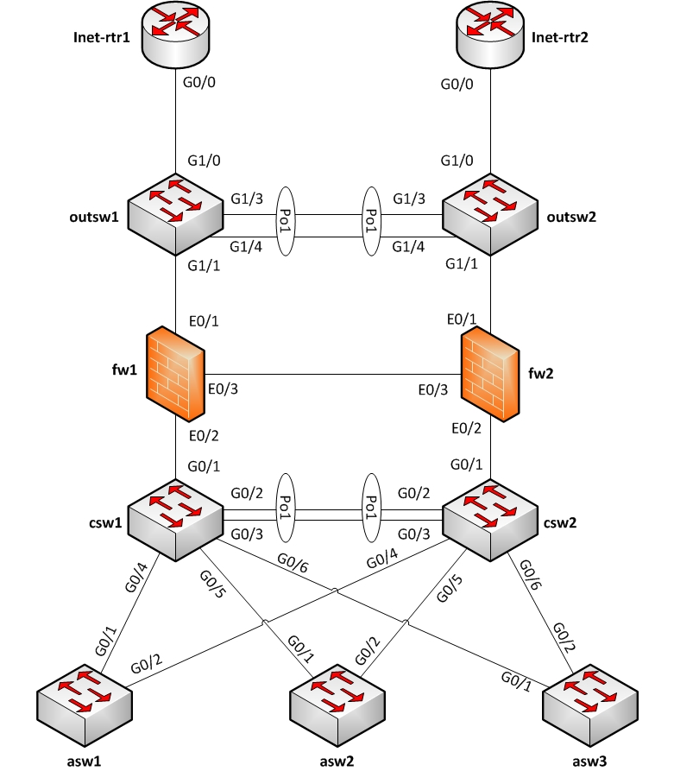

**Evaluation methodology**

In the project, Linux didn't work after I tried to install it. As you can see in , the servers were slow to run and crashed often due to the memory stick being slow. The powershell commands were hard to figure out but I managed to do it in the end.

**Conclusion**

I feel more comfortable using windows server and powershell and that it's increased your knowledge of DCHP, TCP/IP and DNS.